Q1. A rehabilitation center researcher was interested in examining the relationship between physical fitness prior to surgery of persons undergoing corrective knee surgery and time required in physical therapy until successful rehabilitation. Patient records in the rehabilitation center were examined, and 24 male subjects ranging in age from 18 to 30 years who had undergone similar corrective knee surgery during the past year were selected for the study. The number of days required for successful completion of physical therapy and the prior physical fitness status (below average, average, above average) for each patient follow.
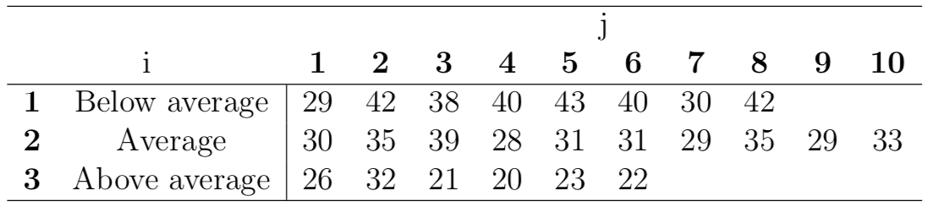
- Prepare the means plot of the data.
- Does the variability of the observations within each factor level appear to be approximately the same for all factor levels (i.e, do the homogeneity test).
- Test whether or not the mean number of days required for successful rehabilitation is the same for the three fitness groups.
- Obtain the analysis of variance table.
- Estimate with a 95% confidence interval the mean number of days required in therapy for persons of average physical fitness.
- Obtain a 95% confidence interval for $μ_{1}-μ_{2}$.
- Test for all pairs of factor level means whether or not they differ; Use the Tukey procedure.

Q2. A researcher wishes to try three different techniques to lower the blood pressure of individuals diagnosed with high blood pressure. The subjects are randomly assigned to three groups; the first group takes medication, the second group exercises, and the third group follows a special diet. After four weeks, the reduction in each person’s blood pressure is recorded. At $α=0.05$, test the claim that there is no difference among the means. The data are shown.
Medication (A) | Exercise (B) | Diet (C)
10 | 6 | 5
12 | 8 | 9
9 | 3 | 12
15 | 0 | 8
13 | 2 | 4

